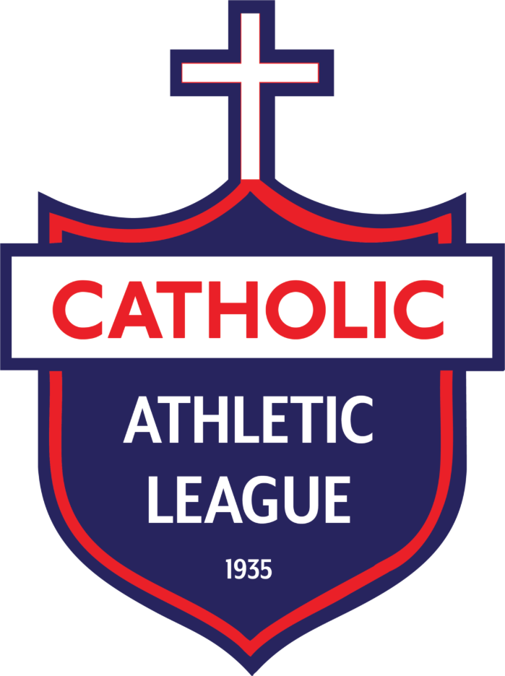
Catholic Athletic League Handbook

Cross Country

Cross Country
- CC-1: Team Makeup
  - CC-1.1: Cross Country is offered in the fall for those in school-grades 4th through 8th.
    - CC-1.1.1: Grammar Division consists of grades 6th through 8th and is separated by boys teams and girls teams.
    - CC-1.1.2: The Junior Division consists of grades 4th and 5th and is considered co-ed.
  - Please see rule G-11.5 of the General Rules & Regulations for more information.
- CC-2: Meets
  - CC-2.1: Rules are followed according to the National Federation of High School Sports unless otherwise specified here.
  - CC-2.2: Meets consist of a course that is no less than 1.85 miles and no more than 2.0 miles for the Grammar Division and a course that is no less than 1.25 miles and no more than 1.50 miles for the Junior Division.
  - CC-2.3: A minimum of five (5) runners per team are needed in order to participate in the championship. Runners from schools with teams with less than 5 athletes may compete in the championship as individuals but the school may not score for a team championship.
  - CC-2.4: Scoring
    - CC-2.4.1: Scoring for both divisions is done by taking the Places of each team's top four (4) runners and totaling them for a team score. At least four (4) runners must finish a race to be scored.
    - CC-2.4.2: In the case of a tie, the total score for the top five (5) runners will be used.
    - CC-2.4.3: Scoring will not be adjusted to remove runners in 6th, 7th, 8th, etc. from the scoring process.
  - CC-2.5: Teams in the Grammar Division will race in the Diocesan Meet, in which each division winner will be decided along the overall winners for the boys and girls teams and the individual runners.
    - CC-2.5.1: Teams in the Junior Division will not race at the Diocesan Meet. Junior Division Champions will be determined based on the season record (performance in all 5 meets). Junior Division Champions will be presented their division trophies at the Diocesan event.
  - CC-2.6: Headphones and earbuds are not permitted to be worn during races. Smartwatches are permitted so long as they do not pose as a distraction to the runner.

