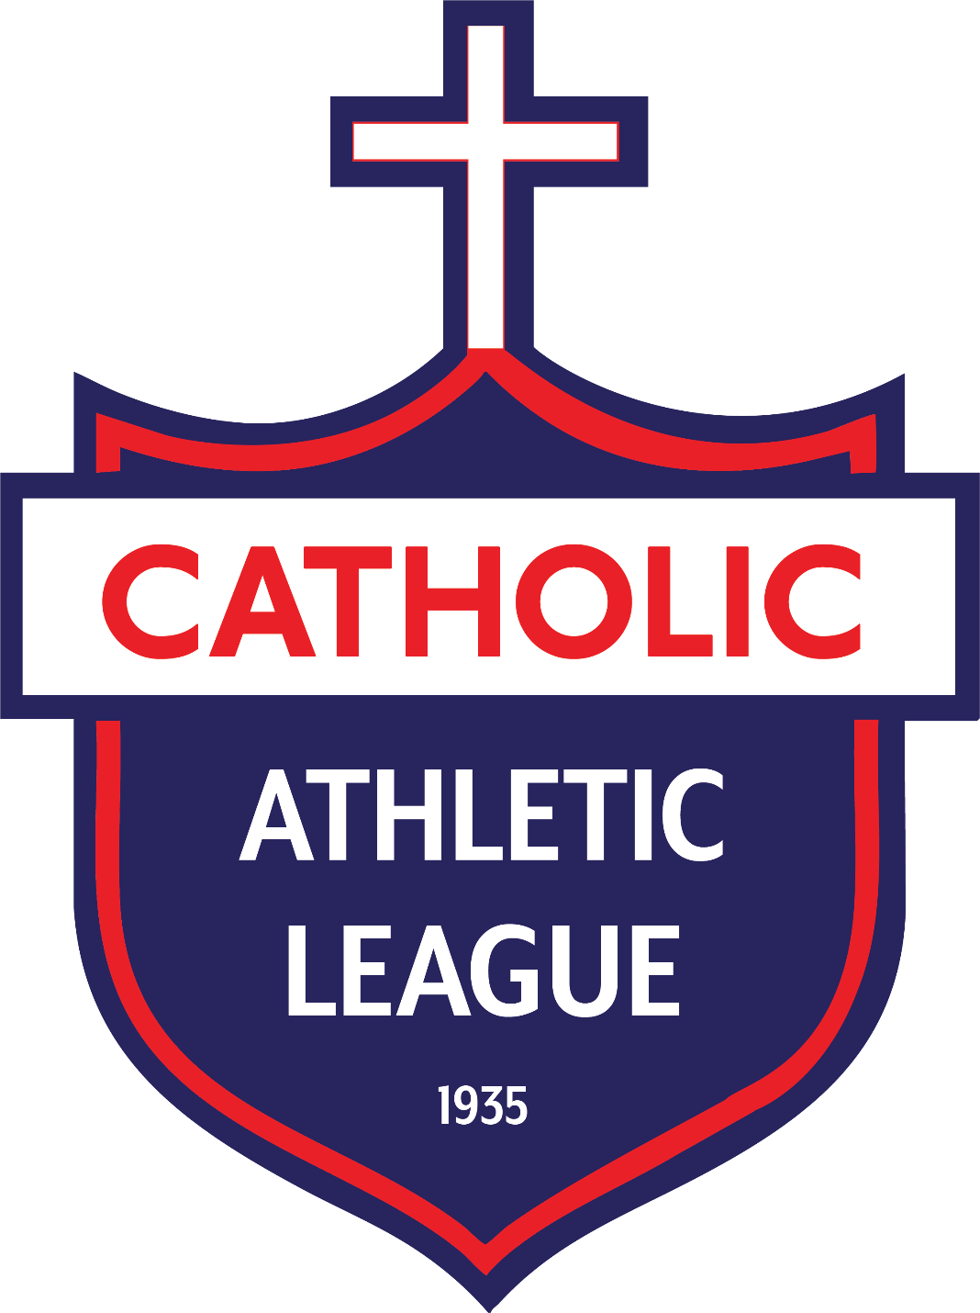

Catholic Athletic League Handbook

Soccer

Soccer
- SO-1: Team Makeup
  - SO-1.1: Soccer is offered as a spring co-ed sport. . Please see rule G-11.5 of the General Rules & Regulations for more information.
  - SO-1.2: The league is divided into two divisions: Grammar Division for those in grades 6th-8th and Junior Division for those in grades 4th and 5th. Players are not eligible to play a division up or down.
  - SO-1.3: All eligible players must play at least 10 minutes of each game during the regular season and the playoffs.
  - SO-1.4: To start a game, a team must have at least 8 players available (7 field players and 1 goalie). In the spirit of Christian competition, the opposing team will match the competing team’s number.
- SO-2: Gameplay
  - SO-2.1: All CAL soccer matches will be played according to the official National Federation of High School Sports, except for any special rules adopted by CAL.
  - SO-2.2: Length of Games:
    - Grammar Division: Two 30-minute halves.
    - Junior Division: Two 25-minute halves.
    - Regular season games do not have overtime.
  - SO-2.3: Playoff Overtime: Overtime consists of two five-minute periods played to completion.
    - SO-2.3.1: If still tied after overtime, the match moves to 5 penalty kicks by any five players.
    - SO-2.3.2: If still tied after the first round of kicks, 5 additional penalty kicks are taken by five different players in a "sudden victory" format (the contest ends if one team makes a kick and the alternating player does not).
  - SO-2.4: Substitutions: Substitutions may occur on any throw-in, corner kick, or goal kick by either team (any dead ball except direct or indirect kicks).
  - SO-2.5: Postponements: The league coordinator reserves the right to postpone games due to emergency or weather. Any games cancelled due to weather will not be rescheduled.
- SO-3: Safety and Division Specific Rules
  - SO-3.1: Heading:
    - Junior Division: No heading is allowed in practice or games. A deliberate head ball results in an indirect free kick for the opposing team from the spot of the offense.
    - Grammar Division: Heading is permitted in games, but coaches are asked to limit heading in practice.
  - SO-3.2: Mercy Rule: When a team is leading by 4-0, that team must play down a player until the opposing team scores. The leading team continues to remove a player for every subsequent goal scored (e.g., 5-0 = play down 2 players; 6-0 = play down 3 players).
- SO-4: Equipment and Uniforms
  - SO-4.1: Uniforms: Schools/parishes must provide colored and numbered T-shirts. Goalies must wear a different colored shirt from the rest of the team.
  - SO-4.2: Player Gear: All players are required to wear approved National Federation shin-guards. No jewelry or metal cleats are allowed; earrings may not be covered with tape.
  - SO-4.3: Ball Size:
    - Junior Division: Size #4 ball.
    - Grammar Division: Size #5 ball.
  - SO-4.4: Safety: All teams must have their own First-Aid Kits at all games and practices.

